AI-Enabled Cloud Cost Management Platforms: Automating Cost Reports, Alerts, and Optimization Recommendations
Praveen Chaitanya Jakku, Individual Researcher, Sr. IEEE Member

Abstract — Cloud computing today is an essential component of modern business, yet its escalating price tag is a significant issue facing organizations. AI-based cloud cost management tools are transforming the way businesses track, optimize, and control their cloud expenses. By leveraging automation, real-time monitoring, anomaly detection, and optimization recommendations, AI-based solutions provide cost-cutting tactics, improve financial projections, and optimize operational effectiveness. These tools utilize machine learning algorithms to track expenses, flag anomalies, and make actionable suggestions to prevent budget overruns. This article explores the various aspects of AI-driven cloud cost management, including cost reporting automation, predictive analysis, cross-cloud optimization, and security compliance monitoring.
Keywords: AI-based Cloud Cost Management, Cloud Computing, Cost Optimization, Automation, Real-time Monitoring, Anomaly Detection, Optimization Recommendations, Machine Learning Algorithms, Cost Reporting Automation, Predictive Analysis, Cross-cloud Optimization, Security Compliance Monitoring, Cost-cutting Tactics, Financial Projections, Operational Effectiveness, Budget Overruns, Hybrid Cloud, Multi-cloud Environments, Intelligent Cost Allocation, Workload Optimization.

1. Introduction
The rapid adoption of cloud computing has resulted in a steep rise in cloud expenditures, making cost optimization a necessity for enterprises. Enterprises often encounter unpredictable costs, wasted resources, and complex pricing models across several cloud providers. Manual management practices involve significant effort, lack real-time capability, and are unable to prevent cost abnormalities from impacting budgets before they happen.
AI-driven cloud cost management platforms overcome these issues by monitoring costs automatically, forecasting trends, and optimizing cloud resource utilization. With the implementation of AI-based tools, businesses are able to gain deep insight into their cloud expenditure, receive real-time alerts for cost variations, and employ predictive analytics to plan future budgets effectively. These platforms enable intelligent cost allocation, workload optimization, and inter-cloud cost management for hybrid cloud and multi-cloud environments (Nama, Pattanayak, & Meka, 2023).
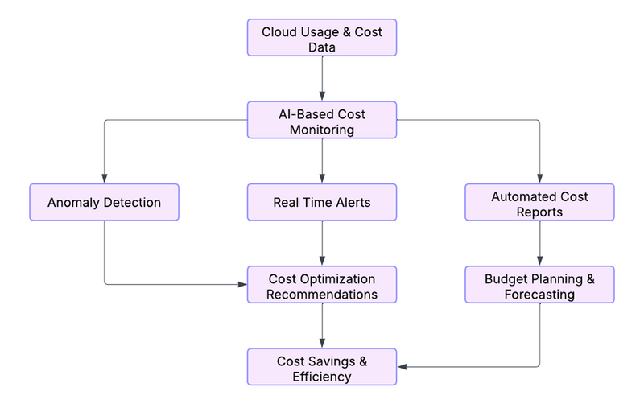
Figure – 1: AI-Driven Cloud Cost Management Workflow
This article addresses the application of AI to cloud cost management, including critical segments such as automated reporting of costs, real-time alerts, optimization recommendations based on AI, tracking of security compliance, and how AI impacts cloud vendor relationships. It also references popular AI-enabled cloud cost management tools, real-life case studies, and strengths and limitations of applying AI to cloud cost governance.
2. Automated Cost Reports
2.1. AI-Powered Cost Tracking and Reporting
Cloud cost management is tedious, especially for organizations dealing with multiple cloud providers. AI-based platforms manage cost tracking by continuously monitoring cloud usage and generating periodic reports. These reports provide an accurate breakdown of costs, allowing companies to identify cost trends and pockets of inefficiency. AI eliminates the need for manual data collection and analysis, as well as providing timely and accurate financial information to stakeholders.
2.2. Scheduled and On-Demand Reporting
Artificial intelligence-enabled cost control software supports automatic as well as on-demand reports. Scheduled reporting runs automatically as scheduled (once a day, week, or month), updating stakeholders periodically with cloud costs. On-demand allows the user to perform real-time cost analysis with no time barriers, supporting fast decision-making. All these facilities support different departments of an enterprise.
- Finance teams receive cloud expense insights for budgeting.
- IT staff can track resource usage and refine deployments.
- Top-level reports are made available to executives for making sound financial choices.
2.3. AI-Powered Cost Insights and Trend Analysis
Outside of basic reporting, AI extends cost analysis through detection of spending trends and areas to save costs. Machine learning algorithms review past performance to forecast cloud spending in the future and give suggestions for how to minimize expenditures. AI has the ability to identify unused resources, propose alternate pricing schemes, and project overruns on a budget so businesses can take anticipatory action before costs become unwieldy (Subhani, 2024).
3. Anomaly Detection for Costs
3.1. Identifying Cost Anomalies and Their Effect
Cost anomalies are unexpected increases or spikes in cloud expenses that do not conform to regular usage patterns. Anomalies may be caused by misconfigured auto-scaling, abrupt traffic surges, or rogue provisioning. Cost anomalies left undetected will contribute to cost overruns, financial losses, and operational inefficiencies. Conventional methods of tracking costs usually miss detecting anomalies in real time, and as such, there will be a delayed response, and there will be unnecessary expense.
3.2. AI-Driven Anomaly Detection Models
AI models also detect unusual spending patterns by continuously analyzing cloud usage data. Machine learning techniques such as time series analysis, regression models, and deep learning algorithms are used to develop baseline spending patterns. If there is a deviation, AI can automatically mark it as an anomaly and send notifications. These models improve over time by learning from historical data, reducing false positives, and maintaining accurate anomaly detection.
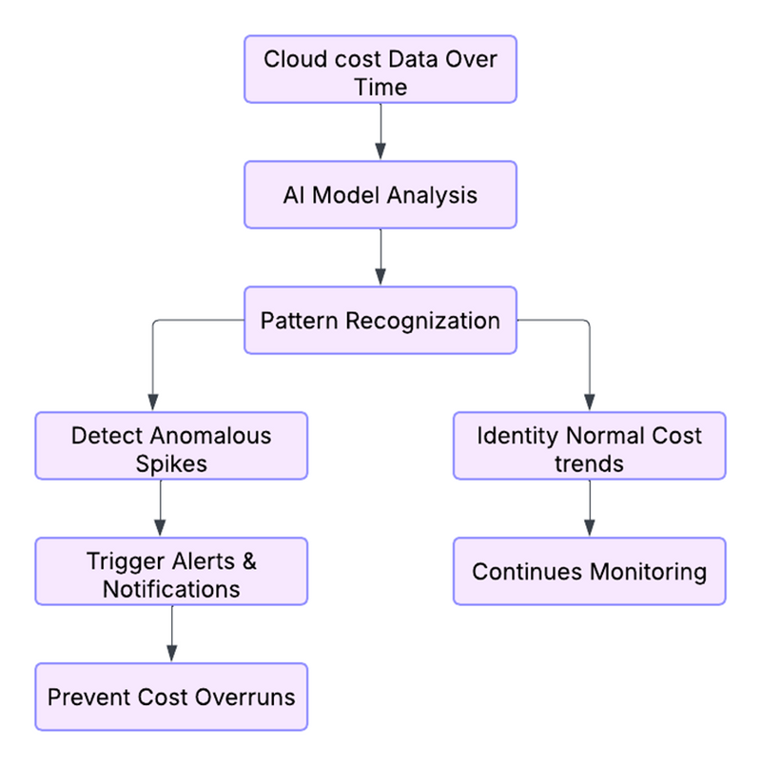
Figure – 2: AI-Powered Cost Anomaly Detection Process
3.3. Real-Life Examples of Cost Peaks and AI Intervention
Consider a sample scenario where a cloud invoice for a company double in an instant due to a mistakenly sized compute instance running in overdrive mode. Without AI monitoring, this error would not be realized until billing is closed. AI-driven cost management has the capability to identify this abnormality in real-time and alert the IT administrators while suggesting corrections with steps such as rightsizing the instance or deactivating unused resources.
A second example is unapproved use of the cloud—if a worker provisions costly services by mistake or there is a security breach leading to unauthorized resource use. AI-powered anomaly detection can identify such outliers and prevent cost overruns through automated responses, such as resource deallocation or access restriction. Through AI-based cost anomaly detection, businesses can prevent financial risks, optimize cloud spending, and ensure operational efficiency while still keeping budget control (Nama, Pattanayak, & Meka, 2023).
4. Real-Time Alerts and Notifications
4.1. AI-Driven Alerting Solutions for Real-Time Cost Deviations
Cloud cost fluctuations can be caused by many reasons such as sudden spikes in workload, misconfiguration of resources, or inefficient provisioning. AI-driven alerting solutions allow businesses to stay ahead of such deviations by continuously watching the cloud spend and identifying unusual trends in real time. These systems, using the algorithms of machine learning, scrutinize historical data and usage behaviors to detect alarmingly high increases in costs beforehand before they create enormous losses. Unlike traditional tools of monitoring, AI-driven systems for alerting can differentiate between normal fluctuations and irregularities to enable only the essential cost variation to trigger a notice (Kumar, 2022).
4.2. Multi-Channel Notifications for Quick Action
When a cost anomaly is detected, AI-powered cloud cost management tools initiate instant notifications to concerned teams through various communication channels. Email notifications provide instant notification to finance and IT administrators so they can take quick corrective action. Cloud dashboards give a common view of cost deviations, making it easy for teams to compare spending patterns and adjust resources as required. Moreover, integration with collaboration tools like Slack and Microsoft Teams ensures cost alerts are shared across departments to enable quick discussion and decision-making. With multiple channels of notifications, businesses can ensure timely action on cost concerns, reducing the risk of over-spending.
4.3. Proactive AI-Powered Risk Mitigation
AI-driven alerting systems go beyond notifications by enabling proactive risk mitigation. With the sudden increase in expense, AI can initiate self-executing actions such as minimizing non-critical resources, suspending idle virtual machines, or recommending configuration tweaks to reduce cloud spending. For instance, if AI discovers that an application is wasting compute resources because of inefficient deployment, it can recommend moving to a cheaper instance type. In addition, AI can enhance cloud security by identifying suspicious spending habits linked to unauthorized access, prompting security teams to probe suspected breaches. With real-time alerts combined with automated cost management, AI-powered solutions allow organizations to remain within budgetary constraints while maximizing cloud resource utilization.
5. Optimization Recommendations
5.1. AI-Powered Cost-Saving Strategies
Artificial intelligence is transforming cloud cost management with intelligent recommendations that allow organizations to reduce costs without affecting performance. AI-powered systems analyze resource utilization, application workloads, and historical spending patterns to suggest cost-saving measures. Rightsizing is one of the most effective methods, where AI recommends the appropriate instance type based on an application's actual-world resource consumption. Through the migration to the optimal instance size, businesses can skip over-provisioning and save on wasteful costs. AI also identifies potential usage of reserved instances for workloads with predictable patterns or spot instances for non-critical workloads to avoid reliance on expensive on-demand resources (Abouelyazid & Xiang, 2019).
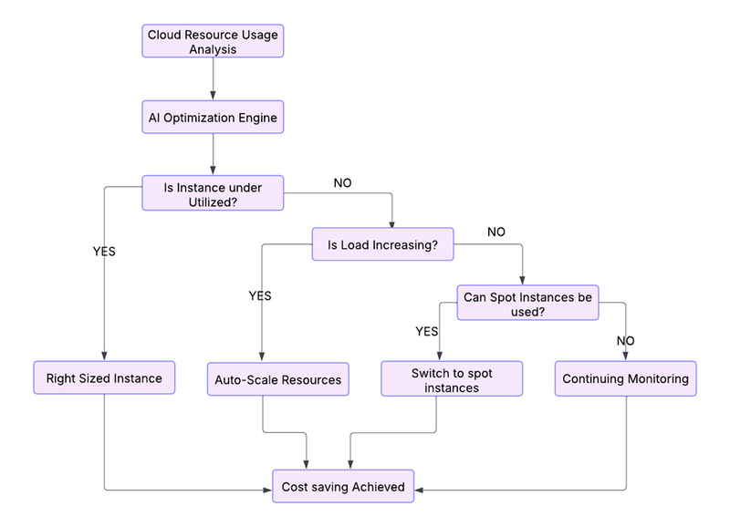
Figure – 3: AI-Driven Cost Optimization Strategies
5.2. Real-Time Performance Measure-Based Workload Optimization
AI workload optimization allows cloud resources to be optimally allocated based on real-time performance measures. Instead of using human efforts, AI optimizes workloads automatically by predicting fluctuation in demand and adjusting resources. For example, in an e-commerce environment, AI can recognize traffic patterns and automatically scale up or down to address times of high shopping demands while reducing capacity during off-peak hours. Similarly, AI-driven optimization platforms assist businesses in balancing workloads among different regions or cloud providers by taking advantage of cost variations for better cost-effectiveness.
5.3. Illustrations of AI-Driven Auto-Scaling and Workload Redistribution
AI-driven cost optimization strategies are already proving their value in various industries. In cloud environments for big data, AI is able to identify when virtual machines are not in use and transfer workloads to fewer servers, thus reducing costs. For example, a video streaming company with periodic traffic volumes can use AI for optimizing its cloud infrastructure such that additional resources will be provided as and when they are required. Additionally, load balancing through AI allows companies to transfer workloads across cloud vendors or data centers depending on live cost analysis. Whenever AI spots one zone's prices rising, it advises on redistributing load to a lower-cost zone without disrupting supply availability. In tracking performance values and costs in real-time, AI helps enterprises make data-driven choices for cutting costs as well as increased operation efficiency.
6. Predictive Analytics for Forecasts
6.1. Traditional-Cost Estimations of the Cloud with AI
Precise cloud cost forecasting is a company's critical challenge, given unpredictable workloads, fluctuating pricing models, and evolving application needs that can provide unexpected costs. AI-based predictive analytics closes this gap by leveraging cloud consumption and spend history data to forecast future spend behavior. Through the use of machine learning models, AI can detect seasonal patterns, spikes in usage, and anomalies in cloud consumption, which allow organizations to predict costs and budget appropriately. These prediction abilities allow businesses to transition from having cost management as a reactive activity to being proactive, reducing financial uncertainty and maximizing resource planning (Abouelyazid & Xiang, 2019).
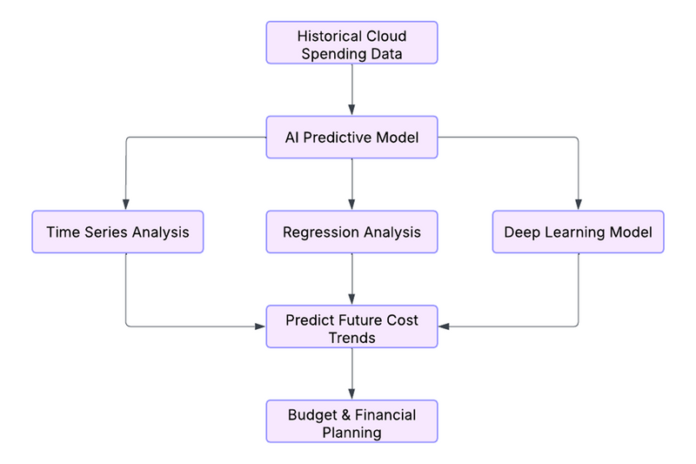
Figure - 4: AI-Based Predictive Analytics for Cloud Cost Forecasting
6.2. AI-Based Budgeting and Financial Planning Forecasting
Businesses are able to utilize AI-based forecast software to budget based on information, such that cloud resources comply with budgetary goals. AI considers past patterns of consumption and simulates various scenarios to project the impact of changes in workload, pricing strategies, and infrastructure configurations on expense. This helps businesses budget ahead of time, streamline budgets per department, and avoid overspending on budgets. For example, an AI model can predict that a company's cloud costs will rise during festive shopping periods due to increased customer visits and recommend budgetary adjustments accordingly. Cloud cost forecasting by AI also enables companies to negotiate better pricing schemes with cloud providers based on future usage patterns.
6.3. AI Models Used in Cloud Cost Forecasting
AI employs various predictive models to enhance the precision of cloud cost forecasting. Time series analysis techniques such as ARIMA (Autoregressive Integrated Moving Average) and Prophet examine past spending trends to forecast future expenses. Models of regression such as linear and polynomial regression identify relationships between cloud pricing and consumption to project spending trends. More advanced deep learning algorithms, such as recurrent neural networks (RNNs) and long short-term memory (LSTM) networks, review enormous quantities of cloud usage information to expose sophisticated patterns and dependencies, making extremely accurate long-term cost prediction. With the use of these AI algorithms, organizations have more insight into cloud spend trends and make highly informed financial decisions.
7. Cost Allocation and Tagging
7.1. AI-Driven Tagging for Resource Categorization
Resource tracking is required for efficient cloud cost management to ensure that every expense is assigned to the appropriate department, project, or application. AI-based tagging automates cloud resource tagging through analysis of metadata, usage patterns, and business requirements. AI-based tools apply and implement standard tags across various cloud environments automatically, minimizing human errors and offering consistency. These tags enable companies to break down cloud expenses into granular categories, making it simpler to analyze spending by team, service, or function.
7.2. Improved Department, Project, and Team Cost Attribution
AI-powered cost attribution enables companies to allocate cloud expenses accurately, offering transparency and accountability. Companies can monitor resource consumption by different departments, projects, and teams with AI-powered tagging. For instance, an organization that has various applications on the cloud is able to use AI to determine which teams consume the most computing power and storage, allowing leadership to make informed cost control decisions. AI also enables automatic chargeback and showback models whereby cloud costs are distributed internally based on usage to instill cost-conscious behavior and fiscal prudence (Ramamoorthi, 2023).
7.3. Best Practices for AI-Enhanced Cloud Cost Governance
In order to gain the maximum from AI-driven cost allocation, organizations must implement best practices in cloud cost governance. Automated tag enforcement helps ensure resources are correctly tagged, reducing errors in billing. Real-time visibility and AI-driven anomaly detection help organizations identify untagged or incorrectly classified resources, improving cost attribution. Dynamic tagging policies learn from cloud infrastructure changes so new workloads and services are accurately classified. Additionally, the integration of AI-tagging with cloud cost management platforms gives visibility, enabling finance and IT organizations to track spend and make informed decisions. With these best practices, organizations are able to increase financial transparency and optimize their cloud spend.
8. Cross-Cloud and Hybrid Cloud Cost Management
8.1. Multi-Cloud and Hybrid Cloud Strategy
With increased adoption of multi-cloud and hybrid clouds by businesses, cost management across AWS, Azure, Google Cloud, and private clouds is a legitimate concern. AI simplifies cloud cost management through real-time tracking and optimization recommendations across multiple cloud vendors. AI platforms aggregate the cost data from several clouds and present a unified view of spending, allowing companies to track costs, identify waste, and capitalize on cost-saving opportunities.
Artificial intelligence-driven cost management software analyzes resource usage across multiple cloud providers and provides recommendations on the most cost-effective configurations. For example, AI can identify redundant workloads on multiple providers and suggest loading them on one more cost-effective provider. AI also allows for automated workload balancing so that applications are being executed on the lowest-cost cloud provider based on performance, availability, and price trends. This approach not only optimizes cloud costs but also optimizes operational efficiency and resource usage.
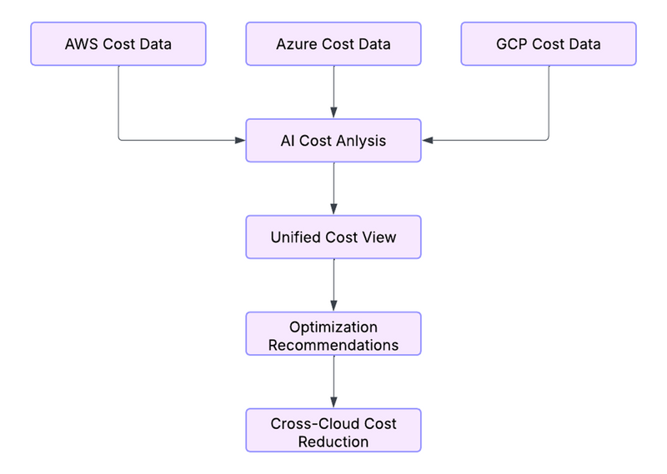
Figure – 5: AI-Enabled Multi-Cloud Cost Management
8.2. Impact of AI on Cloud Vendor Relationships
AI-insights have a far-reaching effect on how firms interact with cloud vendors by enabling transparency into expenditures and usage behaviors. With the application of AI-based analytics, businesses have more awareness of their consumption of clouds, bolstering their negotiation bargaining power against vendors. By allowing for the availability of historical spending records and predictions about future consumption behavior, businesses are able to negotiate better prices, rebates, and custom-made agreements to suit their needs.
AI also enables organizations to implement cost-optimization strategies when working with multiple vendors. AI systems continuously compare cloud pricing models to recommend transferring workloads between providers to take advantage of lower prices or better performance. An active approach like this prevents vendor lock-in and allows organizations to optimize competitive pricing models. In addition, AI-driven predictive analytics allow organizations to forecast upcoming price changes or policy alterations by the cloud providers to proactively adapt their costs (Chen & Li, 2024).
9. Cloud Security and Compliance Monitoring
9.1. AI-Powered Security Risk Monitoring
Cloud security is a high priority for organizations, especially with sensitive data and applications in distributed settings. AI enhances security monitoring by analyzing vast amounts of cloud activity data in real-time, detecting anomalies, and detecting potential threats before they escalate into serious problems. AI-based security solutions constantly scan cloud workloads, access logs, and network traffic to detect unauthorized access attempts, suspicious behavior, or configuration vulnerabilities. Using machine learning models, AI is able to identify normal usage patterns and suspicious activity and provide effective threat detection as well as faster incident response.
9.2. Cost Impact Analysis of Security Tools
AI not just enhances cloud security but also allows organizations to analyze the cost impact of their security strategy. Cloud security appliances like firewalls, intrusion detection systems, and encryption services account for most of the cloud costs. AI-driven cost analysis examines the cost value of security solutions based on their performance, efficiency, and impact on overall cloud spending. For example, AI can recommend automated scaling of security appliances during peak hours to ensure security and cost-effectiveness. Second, AI can identify dormant security services so that businesses can maximize their spending without compromising security (Martins, 2023).
9.3. Regulatory Compliance and AI-Driven Auditing
Monitoring industry regulations such as GDPR, HIPAA, and ISO 27001 is a critical requirement for businesses in the cloud. Compliance management is facilitated by AI with automated auditing being performed, keeping it a company's focus that it is aligned with regulations at all times. Compliance monitoring with artificial intelligence conducts checks on misconfigurations within cloud infrastructures, non-compliant behavior, and unauthorized access to data real-time. These solutions also provide automated compliance and reporting dashboards that help organizations monitor their compliance status and remediate issues at an early point.
AI-powered auditing also reduces the amount of human labor required in reporting compliance. By enforcing policies automatically and analyzing logs, AI helps companies decrease compliance risk, avoid fines, and maintain the cloud environment secure. Additionally, AI enables enhanced cloud governance by applying policies enforced according to industry best practices, hence continuously enhancing security and compliance.
10. Most Popular AI-Powered Cloud Cost Management Solutions
10.1. Cloud Health by VMware
CloudHealth is a leading multi-cloud cost management and governance platform that helps businesses review, optimize, and control cloud spending on AWS, Azure, and Google Cloud. It provides AI-driven insights into cost allocation, security compliance, and resource optimization. With automated cost reporting and anomaly detection, CloudHealth enables organizations to implement cost-saving initiatives and enforce financial governance policies.
10.2. Spot.io
Spot.io optimizes workload and reduces cloud infrastructure costs using AI. It dynamically allocates cloud resources using predictive analytics, enabling workloads to execute on the most cost-efficient instances. The platform is an expert in auto-scaling, instance optimization, and workload scheduling, which helps businesses optimize cloud performance while minimizing unnecessary costs (Chen & Li, 2024).
10.3. CloudCheckr
CloudCheckr is a complete cloud security, compliance, and cost management solution. It provides AI-based recommendations for cost reduction, resource efficiency, and security improvement. By means of automated compliance scanning and cost anomaly detection, CloudCheckr helps organizations maintain a secure and cost-efficient cloud infrastructure with regulatory compliance.
10.4. Kubecost
Kubecost is tailor-made for Kubernetes cost optimization, providing real-time cost visibility and resource efficiency suggestions. AI-powered insights allow companies to monitor Kubernetes workloads and detect unnecessary resource usage, making cloud expenditure efficient. Kubecost also supports multi-cloud and hybrid cloud environments, offering cost insights across various platforms.
10.5. AWS Cost Explorer & Azure Cost Management
AWS Cost Explorer and Azure Cost Management are cloud cost analytics solutions by Amazon Web Services and Microsoft Azure, respectively. They offer artificial intelligence-based cost visualization, forecasting, and budgeting to assist enterprises in optimal management of their cloud expenditure. Drawing on usage history and trend analysis, they present suggestions for cost savings in terms of reserved instance purchase and auto-scaling tuning (Malikireddy, 2020).
11. Benefits of AI for Cloud Cost Management
11.1. Cost Savings through Automation
AI streamlines cost tracking, anomaly detection, and optimization, reducing unnecessary cloud expenses. Automated scaling, for instance right-sizing, and workload scheduling ensure businesses pay only for what they use. AI-powered cost governance also removes the need for human intervention in cost management, reducing the likelihood of human error (Ramamoorthi, 2023).
11.2. Improved Visibility and Active Cost Management
AI provides end-to-end visibility of costs across multi-cloud and hybrid cloud environments so that enterprises can monitor expenditure with ease. AI-driven dashboards and analytics software help organizations keep an eye on spending trends, detect unexpected bursts in costs, and adjust usage accordingly. Preventive alerts make sure deviations in costs are detected and addressed before things spiral out of control.
11.3. Quicker Decision-Making with AI-Powered Insights
AI processes enormous volumes of cost data in real time, delivering actionable insights for timely decision-making. Businesses can rely on AI-driven reports, trend analysis, and predictive models to optimize their cloud strategy without manual processing. This speeds up financial planning, risk assessment, and cost-reduction initiatives.
11.4. Enhanced Forecasting and Budgeting Accuracy
Historical cloud spending information is utilized by predictive analytics with AI to generate very accurate future cost projections. Business organizations can leverage AI models such as time series analysis, regression, and deep learning to improve financial planning and budgeting. AI-driven forecasting guarantees better resource allocation, expenditure optimization, and lower cost overruns.
12. Challenges and Considerations
12.1. Difficulty in implementing AI Model
Deployment of AI in cloud cost management involves sophisticated machine learning algorithms, large data processing capabilities, and plug-and-play integration with cloud providers. Organizations without experience in AI and cloud technology may find developing and deploying AI-enabled solutions challenging. In addition, maintaining the proper interpretation of cost trends and anomalies by AI models requires ongoing monitoring and calibration.
12.2. Data Privacy and Security Concerns
AI cloud cost management solutions manage massive amounts of sensitive financial and operational data. Data security and compliance with industry regulations (for example, GDPR, HIPAA, and SOC 2) is a major consideration. Organizations must implement strong encryption, access controls, and compliance audits to guarantee that data is not compromised and accessed by unapproved staff. AI models also must adhere to privacy policies when processing cost patterns (Adenekan, 2022).
12.3. Requirement for Continuous AI Model Training for Accuracy
Cloud expenditure is predicted using AI models based on historical data, and resources are assigned optimally. Pricing models, usage patterns, business needs, and cloud schemes keep evolving, requiring frequent training of AI models. Without regular updates and retraining, AI recommendations become stale, and ineffective cost control practices emerge. Organizations must incur costs on continuous upgrades in machine learning to maintain the effectiveness of AI-driven solutions.
12.4. Dependence on Cloud Vendor Integrations
AI-powered cost management tools are often rooted in integrations with cloud vendors such as AWS, Azure, and Google Cloud. Differences in pricing models, services, and API access may complicate the achievement of effortless multi-cloud cost optimization. Businesses with operations across multiple clouds risk vendor lock-in, compatibility issues, and variable AI-powered recommendations because of divergent cloud provider policies.
12.5. Implementing Cloud Cost Management Solutions
One of the main problems of cloud cost transparency is the fact that it's not possible to assign costs precisely to workloads. For instance, in Google Cloud Dataproc, APIs usually display the cost of virtual machines (VMs) and not workload-related costs within the cluster. It becomes challenging for organizations to measure the real cost of a particular workload due to this lack of granularity, causing inefficiencies in budget planning and optimization processes.
Cloud cost management platforms powered by AI address these constraints with sophisticated workload attribution and machine learning-driven cost mapping. These systems inspect patterns of workload execution, map them to resource usage, and deliver workload-centric cost decomposition. Moreover, AI is capable of dynamically assigning costs depending on job execution time, volume of data processed, and utilization of resources instead of fixed VM-based costing schemes.
Another significant challenge is multi-cloud expense complexity, under which organizations make use of combined AWS, Azure, and Google Cloud services. Each cloud supplier has its distinct billing structures, which complicate cross-platform pricing comparisons. AI solutions fill in the gap through cost normalization capabilities, enabling businesses to compare across providers with homogeneous metrics.
13. Deployment Models and Expense Considerations
13.1. Deployment Models
AI-powered cloud expense management systems can be set up in three main ways:
Cloud-Based SaaS Deployment: These are completely managed by third-party vendors like Apptio Cloudability, Spot.io, and CloudHealth. They integrate smoothly with cloud platforms and offer AI-powered insights without demanding infrastructure management. This method might raise cloud egress fees and logging charges since high levels of billing and monitoring data are scanned externally.
On-Premise Deployment: Certain businesses prefer to have cost management platforms hosted in their own data centers to avoid egress charges and have complete control over data security. However, on-premises AI deployment necessitates high-performance infrastructure, which is a substantial operational expense.
Hybrid Deployment: In this strategy, the AI engine is executed on-premises with data ingestion through cloud APIs. This strategy minimizes egress expenses while enjoying the benefits of AI-powered cost optimization. It strikes a balance between security, performance, and cost-effectiveness.
13.2. Cost of Implementing AI-Enabled Cloud Cost Management Platforms
The implementation cost of AI-powered cost management platforms varies based on licensing, infrastructure, and cloud service fees.
Software Licensing Costs: SaaS platforms are generally billed on a per VM, per container, or a percentage of cloud expenditure basis. Solutions such as Apptio Cloudability can be 2-5% of an organization's overall cloud spending.
Infrastructure and AI Processing Charges: Large compute resources are needed for on-prem deployments to process cloud bill and utilization data. Prices range based on the size of data and the complexity of AI models.
Cloud Logging and Egress Charges: AI-powered cost management platforms constantly consume and process cloud usage logs. Large-scale data transfers, if the platform is hosted externally, can lead to higher egress charges. Cloud providers also charge for logging and monitoring services, which can contribute to the overall cost of ownership.
Increased Vendor Negotiations with AI: One of the strongest uses of AI for cost management is its capacity to predict pricing trends and bolster vendor negotiation. Cloud cost models are very dynamic, and companies find it difficult to anticipate costs in the future. AI-based cost analysis platforms use past spending habits, workload trends, and changes in cloud provider pricing to create accurate cost forecasts.
For instance, an enterprise applying AWS Reserved Instances (RIs) or Google Cloud Committed Use Discounts (CUDs) can use AI to forecast the ideal reservation plans so that they only commit to the correct capacity and do not underutilize. AI also helps achieve automated bid optimization for spot instances, which saves the minimum rates for short-term workloads. By incorporating predictive cost modeling, organizations can fortify vendor negotiations, securing improved discounts and price adjustments based on AI-driven spending forecasts.
14. Case Studies
14.1. Airbnb's AI-Driven Cloud Cost Optimization
Airbnb, a leading vacation rental online platform, was facing escalating cloud costs due to fluctuating demand and inconsistent workloads. To solve the problem, Airbnb implemented an AI-based cost optimization solution that leveraged machine learning algorithms to analyze historical usage patterns and predict future demand. The AI platform scaled instances automatically, mapped workloads for optimal allocation, and identified unused resources, saving the company 30% on cloud costs without a compromise in performance and uptime.
14.2. Netflix's AI-Based Cloud Resource Management
Netflix, a global streaming giant, relies on AWS to host its content delivery system. With video content streamed by millions of viewers every day, Netflix needed a solution to optimize cloud expense and not compromise performance. With AI-based auto-scaling and predictive analytics, Netflix could efficiently forecast spikes in demand, automate server provisioning, and eliminate wasteful expenditure. In turn, Netflix improved cost-effectiveness by 40% without compromising the seamless streaming experience of users.
14.3. Uber's Multi-Cloud Cost Optimization Strategy
Uber has a highly distributed cloud infrastructure on AWS, Google Cloud, and private data centers. To manage costs effectively, Uber adopted an AI-based multi-cloud optimization approach that provided real-time cost visibility, automated cost tagging, and anomaly detection. Through AI-based cross-cloud cost comparison, Uber negotiated better prices with cloud providers and optimized compute resource usage, which yielded millions of dollars in cost savings every year (Müller & Weber, 2024).
14.4. AI-Driven Cost Optimization at a Global E-commerce Company
A global e-commerce leader deployed an AI-powered cloud cost management platform to optimize AWS and Google Cloud spending. The outcomes were:
- 25% decrease in total cloud spending by discovering idle and underused resources.
- 40% improvement in reservation efficiency, providing optimal usage of AWS Reserved Instances.
- Auto-scaling workloads, cutting idle compute cost by 30%.
These quantifiable results point to the way AI can radically enhance cloud cost effectiveness by optimizing resource utilization and forecasting.
14.5. AI-Based Cost Savings for Small Organizations
Although giant companies like Netflix can develop custom AI-powered cost management tools within their organizations, small companies without much AI competence might not be able to introduce similar functionality. Nevertheless, AI-powered cost saving is still achievable through third-party solutions that have pre-developed machine learning models and automation tools. For smaller companies, cloud cost management platforms like CloudHealth by VMware, Apptio Cloudability, and AWS Cost Explorer offer:
- Automated Cost Anomaly Detection: AI notifies users if cloud expenditure differs from normal behavior.
- Resource Rightsizing Recommendations: Machine learning proposes the best instance sizes to avoid overprovisioning.
- Predictive Budgeting and Forecasting: AI-powered tools enable small businesses to better budget their cloud expenditure.
Through embracing AI-based SaaS tools, smaller firms can achieve cost savings without the need for AI specialists.
These case studies reveal how AI is transforming cloud cost management so that businesses can predict, optimize, and automate cloud expenses. While there are complexities, the benefits of cost optimization through AI far outweigh complexity, and therefore it is a must-have strategy for organizations on a scale.
Conclusion
AI-based cloud cost management has become a revolutionary method for companies looking to streamline their cloud spending without compromising performance and efficiency. Through the use of AI technologies like automation, real-time monitoring, anomaly detection, predictive analytics, and cost optimization, companies can manage their cloud expenses proactively, enhance resource utilization, and avoid surprise budget blowouts. The use of AI facilitates automated cost tracking, anomaly identification, real-time notifications, and smart optimization suggestions, minimizing the requirement for human intervention. In addition, AI-based forecasting and cost allocation enable companies to make data-driven budgeting choices, guaranteeing financial predictability and operational effectiveness. In hybrid cloud and multi-cloud environments, AI facilitates unified cost visibility across providers, improving cloud vendor negotiations and strategic cost planning.
Though beneficial, AI-based cloud cost management also presents issues like model complexity, security issues, and reliance on cloud provider integrations. Still, positive implementations by market leaders like Airbnb, Netflix, and Uber prove the substantial cost savings and efficiency gains AI can deliver. With continued cloud uptake, organizations are now required to spend in AI-fueled cost management models in order to remain competitive, eliminate waste, and maximize returns. Through iterative AI model enhancement and incorporation of best practices, organizations can develop lasting cloud cost optimization and enjoy fiscal control over the rapidly changing cloud computing paradigm (Malikireddy, 2020).
References
[1] Malikireddy, S. K. R. (2020). Transforming SME cloud cost management with artificial intelligence. International Journal of Cloud Computing and Services Science, 9(3), 112-124. https://www.researchgate.net/profile/Sai-Kiran-Reddy-Malikireddy-3/publication/387725162_Transforming_SME_Cloud_Cost_Management_with_Artificial_Intelligence/links/67797264fb9aff6eaa05e4cd/Transforming-SME-Cloud-Cost-Management-with-Artificial-Intelligence.pdf
[2] Nama, P., Pattanayak, S., & Meka, H. S. (2023). AI-driven innovations in cloud computing: Transforming scalability, resource management, and predictive analytics in distributed systems. International Research Journal of Modernization in Engineering Technology and Science, 5(12), 4165. https://www.researchgate.net/profile/Prathyusha-Nama/publication/385215156_AI-DRIVEN_INNOVATIONS_IN_CLOUD_COMPUTING_TRANSFORMING_SCALABILITY_RESOURCE_MANAGEMENT_AND_PREDICTIVE_ANALYTICS_IN_DISTRIBUTED_SYSTEMS/links/671b08192b65f6174dc85632/AI-DRIVEN-INNOVATIONS-IN-CLOUD-COMPUTING-TRANSFORMING-SCALABILITY-RESOURCE-MANAGEMENT-AND-PREDICTIVE-ANALYTICS-IN-DISTRIBUTED-SYSTEMS.pdf
[3] Adenekan, T. K. (2022). AI-Optimized Cost Management in SME Cloud Environments: A Framework for Scalability and Sustainability. https://www.researchgate.net/profile/Tobiloba-Adenekan/publication/387995723_AI-Optimized_Cost_Management_in_SME_Cloud_Environments_A_Framework_for_Scalability_and_Sustainability/links/67862daa2be36743a5d56f55/AI-Optimized-Cost-Management-in-SME-Cloud-Environments-A-Framework-for-Scalability-and-Sustainability.pdf
[4] Chen, L., & Li, M. (2024). AI-Enabled Cloud Platforms: Revolutionizing Software Development. Asian American Research Letters Journal, 1(1). https://aarlj.com/index.php/AARLJ/article/view/13
[5] Müller, O., & Weber, S. (2024). AI-Enabled Cloud Platforms: Revolutionizing Software Development. MZ Journal of Artificial Intelligence, 1(1), 1-10. http://mzjournal.com/index.php/MZJAI/article/view/40
[6] Martins, O. (2023). Optimizing Cloud Expenditure for SMEs: AI-Enabled Cost Forecasting and Resource Allocation Strategies. https://www.researchgate.net/profile/Olufunke-Martins/publication/388707391_Optimizing_Cloud_Expenditure_for_SMEs_AI-Enabled_Cost_Forecasting_and_Resource_Allocation_Strategies/links/67a32f57207c0c20fa78c708/Optimizing-Cloud-Expenditure-for-SMEs-AI-Enabled-Cost-Forecasting-and-Resource-Allocation-Strategies.pdf
[7] Ramamoorthi, V. (2023). Applications of AI in Cloud Computing: Transforming Industries and Future Opportunities. International Journal of Scientific Research in Computer Science, Engineering and Information Technology, 9(4), 472-483. https://www.researchgate.net/profile/Vijay-Ramamoorthi/publication/386456329_Applications_of_AI_in_Cloud_Computing_Transforming_Industries_and_Future_Opportunities/links/6751da6f70fb742879dc4a6c/Applications-of-AI-in-Cloud-Computing-Transforming-Industries-and-Future-Opportunities.pdf
[8] Kumar, B. (2022). Challenges and Solutions for Integrating AI with Multi-Cloud Architectures. International Journal of Multidisciplinary Innovation and Research Methodology, ISSN: 2960-2068, 1(1), 71-77. https://ijmirm.com/index.php/ijmirm/article/view/76
[9] Abouelyazid, M., & Xiang, C. (2019). Architectures for AI Integration in Next-Generation Cloud Infrastructure, Development, Security, and Management. International Journal of Information and Cybersecurity, 3(1), 1-19. https://publications.dlpress.org/index.php/ijic/article/view/92
[10] Subhani, M. (2024). Impact of AI on Enterprise Cloud-Based Integrations and Automation. International Journal of Scientific Research in Computer Science, Engineering and Information Technology, 10, 1393-1401. https://hal.science/hal-04924438/

